* Install Latest version of install
* Enable updates
  + Subscription to proxmox
  + Enable unstable updates
    - add lines in source lsit  
      #nano /etc/apt/sources.list  
      add lines“# non production use  
      dep <http://download.proxmox.com/debian> buster pve-no-subscription"
    - edit enterprise list  
      nano /etc/apt/sources.list.d/pve-enterprise.list  
      comment line (#deb https://enterprise.proxmox.com/debian/pve bullseye pve-enterprise)
    - Update lsit  
      apt-get update
    - Distribution upgrade  
      apt dist-upgrade
* Configuring Storage
  + Creating ZFS pool
  + Smart disk monitoring check
* Turn on IOMMU
* VLan Aware
  + Vlain Restrict  
    edit /etc/network/interfaces  
    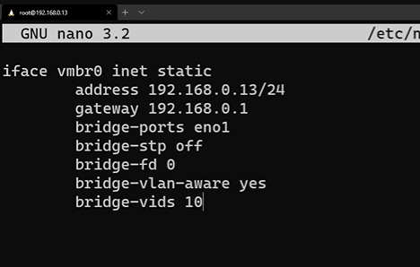
  + Vlan tag in VM network interface
* Add smb/nfs share
* Schedual Backups  
  go to data centet>backups>add>set job  
  compression lever: zstd,mode,
* Create a backup and Snapshoot after Installing VM/Container
* VirtIO and other ISOs uploading
* NIC Teaming (Ether Channel) configure.
* Create Template